COVID-19 Disability Rights Monitor

Summary – May 18-24, 2020

Submissions
Total submissions: 108 (last week: 140)

Type of respondents

Individuals: 107
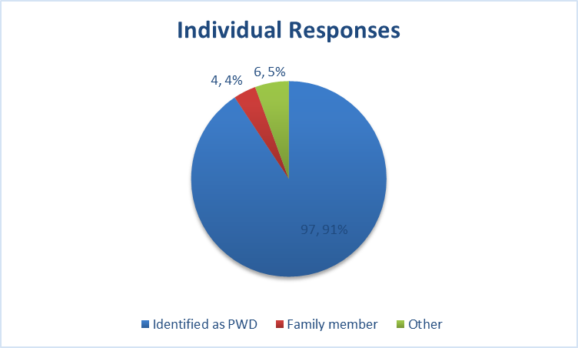
Of the 107 respondents, 66 are women, 40 men and 1 preferred not to disclose or selected other. They identified themselves as:

Identified as PWD 97 – 97,91%
Family member 4 – 4,4%
Other 6 – 6,5%

The category “other” includes persons which other disabilities not listed in the questionnaire, such as, learning disability, borderline personality disorder and clinical depression as well as a person that not identified as having a disability.
Further, 67 people claimed they live in community, while 4 people claimed that they live in an institution. Of those persons with disability living in institutions, they stated they live in university housing, home for elderly care and a dormitory for persons with disability

National Human Rights Institutions – 1 response
- Mozambique: National Human Rights Commission (Comissão Nacional de Direitos Humanos CNDH), unit for women, children and persons with disabilities

Submissions per country

In the week 18 May – 24 May, there were submissions from 43 countries. Countries with most responses are Countries with the most responses are France (46), Germany (11) and Canada (11). The list of the top 10 countries from where highest number of submissions were submitted are illustrated below:

No | Country | Abbr | Number of responses
1 | France | FR | 46
2 | Germany | DE | 11
3 | Canada | CA | 11
4 | United Kingdom | GB | 6
5 | United States of America | US | 4
6 | Slovenia | SI | 3
7 | Nigeria | NG | 2
8 | Switzerland | CH | 2
9 | Denmark | DK | 2
10 | Tanzania | TZ | 2
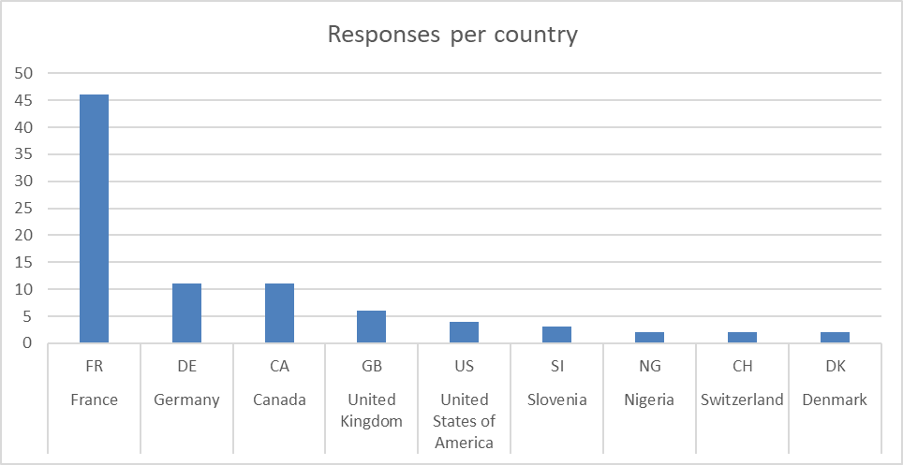

Summary of narrative responses

The responses from persons with disabilities regarding the concerns they have in the COVID-19, largely indicate that most issues reported in previous are still a concern. In particular, persons with disabilities experienced discrimination and felt that stereotypes continue to shape policy decisions or behaviour of those that assist them. It is still the case that people talk about government not taking disability-sensitive measures at all, or they are insufficient. Largely, they state that measures taken during the sanitary crisis have been too general in scope and do not meet the particular and different needs of different categories of disabilities.

This systemic issue has created feelings of abandonment and fear, which also made some respondents feeling isolated. They are concerned that their life will never return to normal after the crisis, in fear that the occupancy activities and health services they previously had access to never return. Persons with disabilities feel forgotten. They talked about not having any or too little support, which made it necessary to rely on their families or kindness of their neighbours.

People are generally concerned about understanding the situation they are in, how to protect their health and secure access to health services, medical treatment and food. This includes:
- Gaining access to information that is appropriate to their needs;
- Concern they or their family might not have sufficient money to buy medication, food or access to medical assistance they need;
- Fear that the health and medical services they had access to before the crisis will not return;
- Fear they might either be denied treatment for Covid-19 due to their disability or fear that they will not be treated at all, if medical practitioners have to decide between treating a person with disability or another with no disability;

Many responses express outrage for insufficient or inadequate action by governments, which only exacerbated the psychological and financial pressure that persons with disability already felt in their daily life before the crisis.

