COVID-19 Disability Rights Monitor

Summary – April 20-26, 2020

Submissions
Total submissions: 588 (last week: )

Type of respondents

Individuals: 578
Of the 578 respondents, 385 are women,167 men and 26 preferred not to disclose or selected other. They identified themselves as:
(insert chart?)
Identified as PWD 240 – 41.52%
Family member 136 – 23.53%
Organization 125 – 21.63%
Other 77 – 13.32%
The category “other” include NGOs, disability rights organisations, international and local human rights organizations, service providers, mental health professionals, physicians, educators, students and researchers, centres for social work etc.
There were 15 people who claimed that they live in an institution. However, only 7 of them identified themselves as persons with disabilities while others are working there.

Government: 7 responses
- Republic of Serbia (member of parliament)
- Mexico: 1 special school educator and 1 external advisor
- Rwanda: National Council of Persons with Disabilities
- United States: Washington State Independent Living Council and Idaho State Independent Living Council
- Hungary: not disclosed
National Human Rights Institutions – 3 responses
- Congo: Union for Promotion / Protection, Human Rights Defense and the Environment-UPDDHE/GL
- Ethiopia: University of Gonder
- India: CORD – Community Based Inclusion and Rehabilitation for persons with disabilities

Submissions per country

In the week 20 April – 26 April, there were submissions from 82 countries. Countries with most responses are Countries with the most responses are Mexico (60), United States (52) and Hungary (45). New country entries include …

No | Country | Abbr | Number of responses
1 | Mexico | MX | 60
2 | United States | US | 52
3 | Hungary | HU | 45
4 | Germany | DE | 31
5 | France | FR | 29
6 | Canada | CA | 27
7 | India | IN | 21
8 | Serbia | RS | 17
9 | Bulgaria | BG | 16
10 | United Kingdom | GB | 16

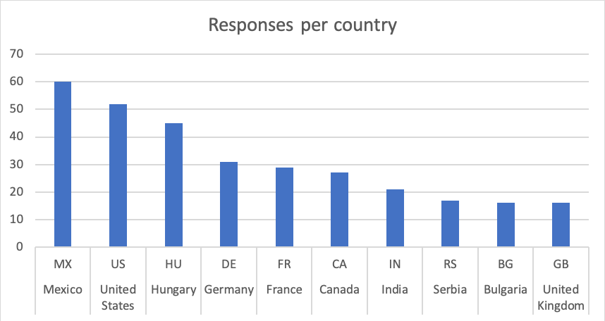

Summary of narrative responses

The responses from persons with disabilities regarding the concerns they have in the COVID-19, in general terms, are the presence of stereotypes against people with disabilities, discrimination. People talk about restrictive, inappropriate, or insufficient measures. The idea of a structural problem prevails where people with disabilities are not taken into account. There is a sense of hopelessness. Some people talk about the possible increase in suicide. People think that the measures taken do not include all disabilities; they feel more vulnerable; they talk about information barriers; they are concerned about educational issues and access to food and different services.

Persons with disabilities feel forgotten. They talked about not having any support, only rely on their families. They are concerned about depression, behavioral problems, loneliness. They mentioned the inaccessibility of the information, inability to access emergency care, personal assistance, and therapies. Limited access to devices, limited income.

People are generally concerned for their health:
- Consequences of them not getting rehabilitation due to the crisis
- Fear they might not be able to access medical treatment they need because of the crisis
- Fear they might be denied treatment for Covid-19 due to their disability or fear that they will die if they catch the virus because of their underlying condition.

Many concerns are expressed that the current situation will have serious consequences to the mental health of people, especially when it comes to people who have existing psychosocial disabilities.

